Assignment -1

**Objective:**

To create a basic virtual environment in Unity that includes a ground plane, a skybox, environmental objects, lighting, and simple VR interaction. The player should be able to grab and move the grabale objects in the environment

**Guidelines:**

* Try to complete as many tasks as possible.
* Each task will earn some points denoted in the corresponding brackets.
* Submit the final Project as a github repo.
* Create one document with screenshots and explanation of each task.
* Create a screen record to show the demo of the task completed.
* Modify your gamelogic in the given C# scripts.

**Task 1:** Set Up Your Unity Project & Configure the VR Environment [5 marks]

# Create a New Unity Project

1. Open Unity Hub and click "New" to start a new project..

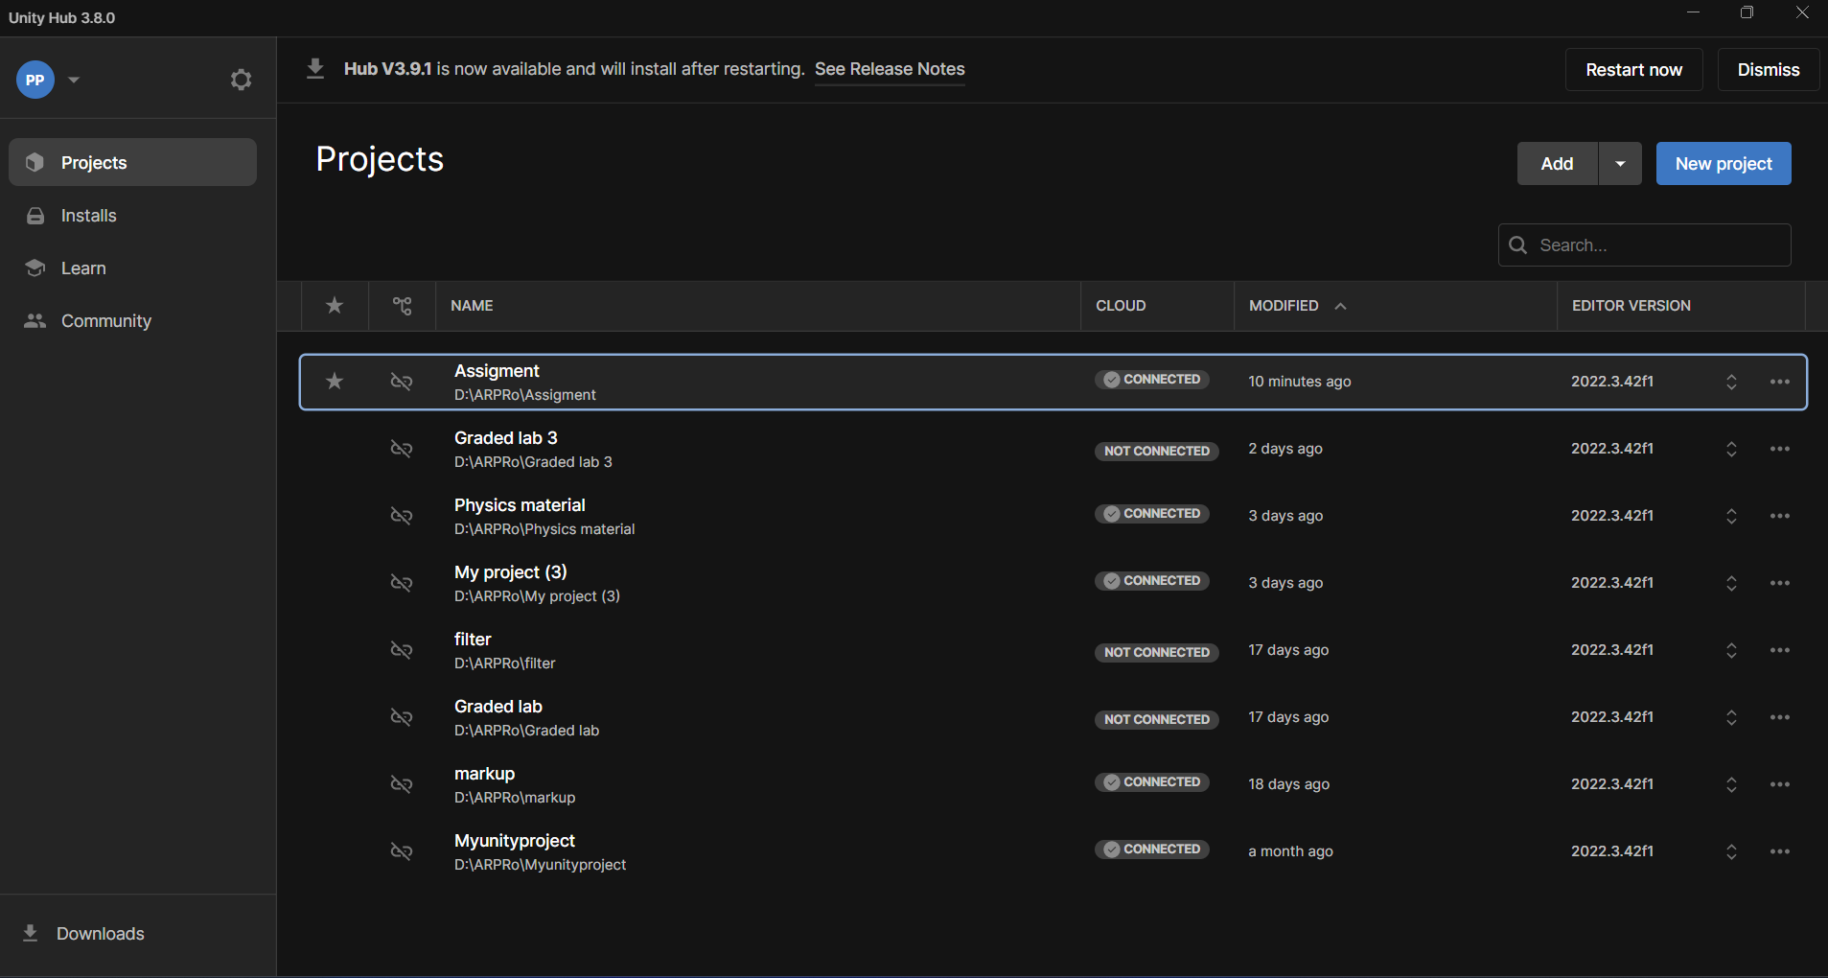

1. Pick a template or choose "3D Built-in Render Pipeline" to begin a simple 3D project.

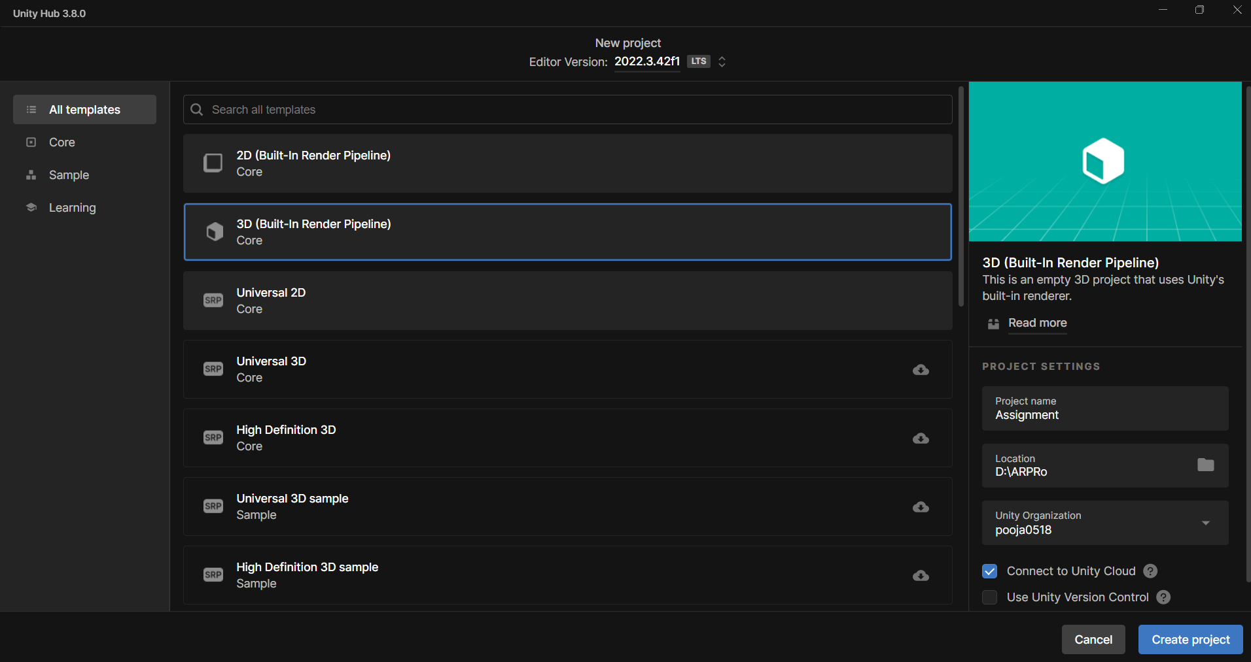

1. Select the project name and location, then click “Create Project.”

# Configure the VR Environment

1. In the Unity Editor, navigate to "Window" and select "Package Manager.".”

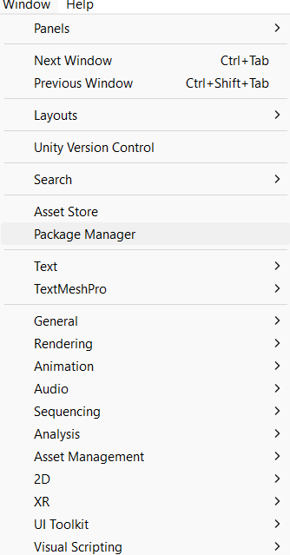

1. From the drop-down menu in the top left, choose "Packages: Unity Registry."
2. Look for "XR Plugin Management" and install it.

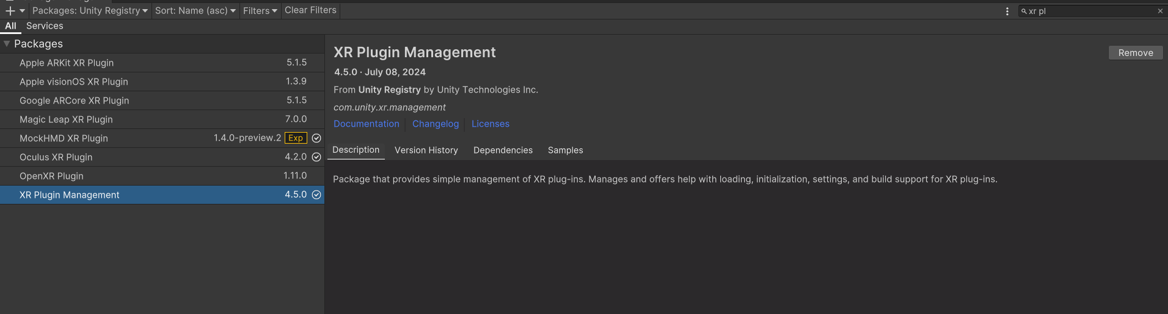

**Configure XR Settings**

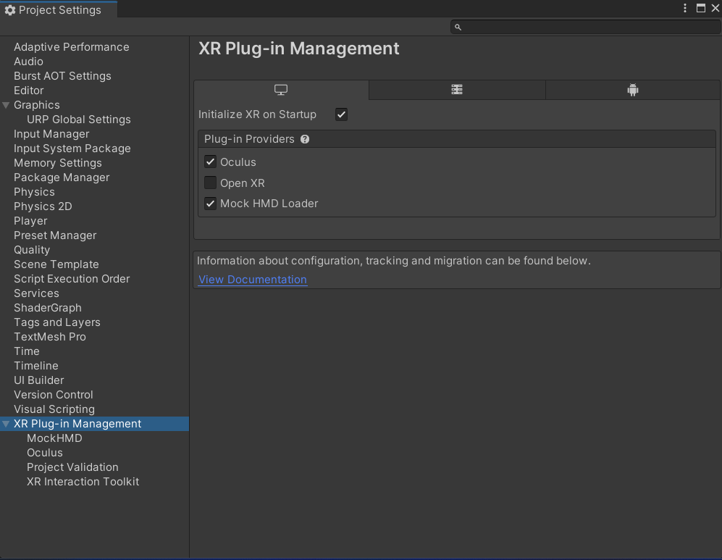

1. Make sure "Oculus" and "Mock HMD Loader" are checked, and uncheck other VR platforms.
2. Do the same for the Android platform and check "Initialize XR on Startup.”

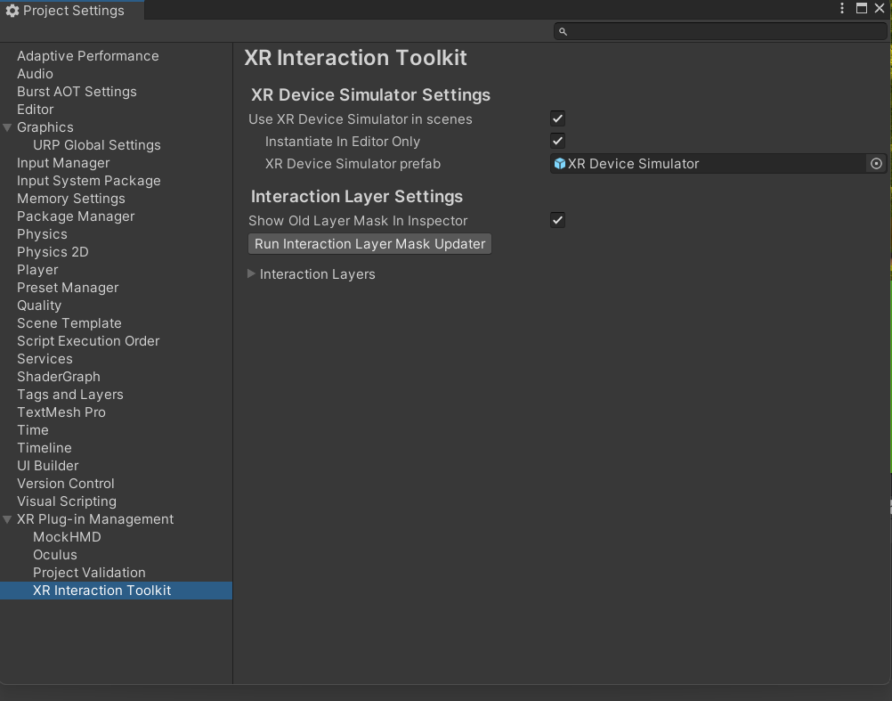

**Task 2:** Create the Ground Plane [5 marks]

● Make a bigger ground area to allow player movement.

● You can use a Terrain object to do this.

# Took the Asset for the Asset Store:

# 

**Task 3:** Add a Skybox [5 marks]

* You can use sky presets
* Try to make it more detailed and more interesting

1. Add the Skybox to Your Scene

* Open the Lighting window by going to Window > Rendering > Lighting.
* In the Environment tab, find the Skybox Material section. Click the small circle next to it and choose the Skybox material you want to use from the list.

**Task 4:** Add Environment Objects [15 marks]

* Use assets to make the environment more engaging.
* Spawn grabbable objects at random locations.

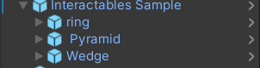

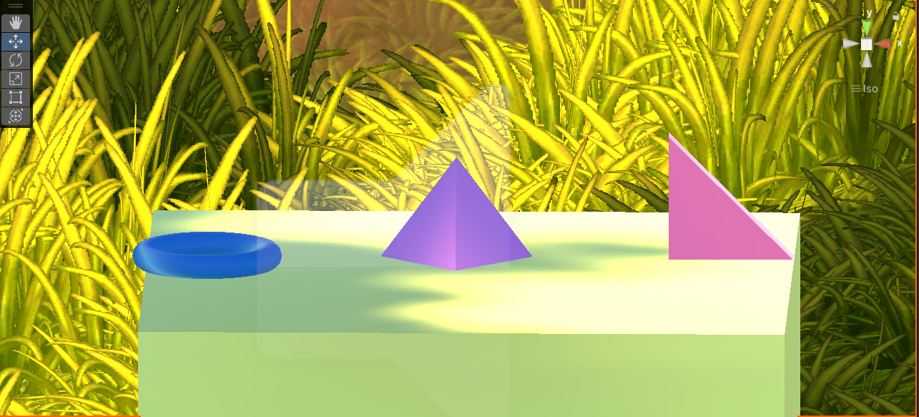

**Task 6**: Configure Lighting and Shadows [5 marks]

1. Set Up Your Lighting
   * Directional Light: This acts as your main light source, similar to the sun. You might already have one in your scene, but if not, you can add it by going to GameObject > Light > Directional Light.
     + Adjust the Intensity to control the brightness of the light..
     + Change the Color to set the scene's mood—warm colors for a sunset effect or cool colors for a night setting..
     + Rotate the light to decide how and where the shadows appear.
2. Turn on Shadows
   * Select the Directional Light and make sure the Cast Shadows option is enabled in the Inspector.
   * Decide if you want Soft Shadows (which look blurry and realistic) or Hard Shadows (which have sharp edges and are more defined).
     + Soft Shadows work well for natural, diffused lighting.
     + Hard Shadows create a more direct and clear outline for your shadows.

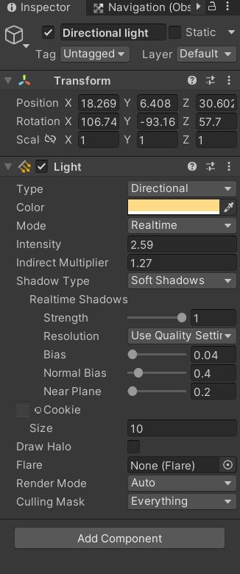

**Task 7:** Add Audio [5 marks]

# Import Your Audio Files

• Start by adding your audio file (such as MP3, WAV, or another format) to your Unity project. The easiest way is to drag and drop the file directly into your Assets folder. You can also go to Assets > Import New Asset and select your file from there.

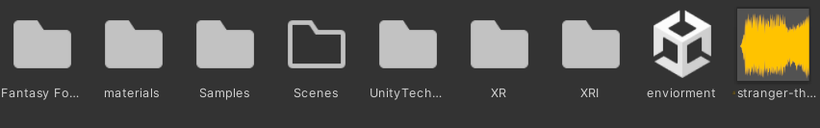

**2. Add an Audio Source:**

* The Audio Source plays sound in Unity, so attach it to an object in your scene.
* Choose the GameObject for the sound source—like the main camera (for background music), a character, or an object in the environment.

* After selecting your GameObject, go to Component > Audio > Audio Source.
* In the Inspector, drag your imported audio file into the Audio Clip field.

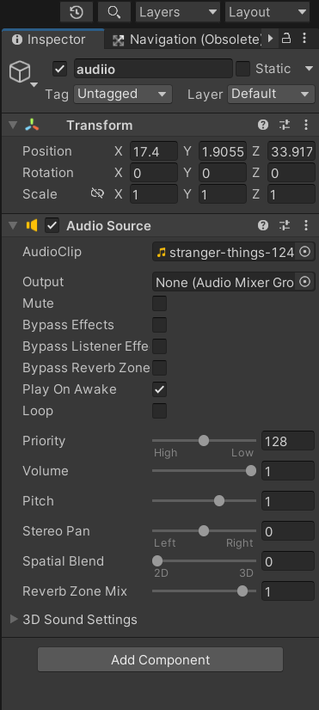

**Task 8:** Implement Basic VR Interaction [25 marks]

* + Create a Grabbable Object

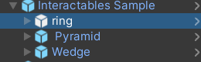

* + Add Grabbable and Grabber Components

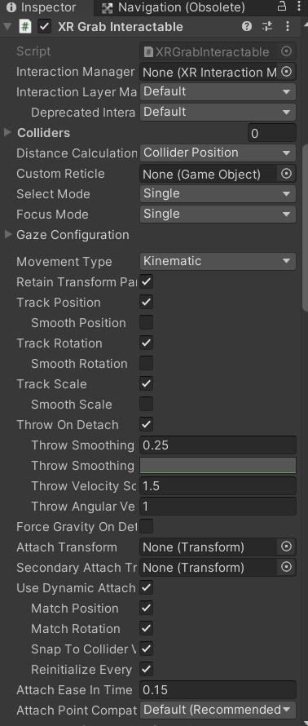

**Task 9:** Write the VR Interaction Script [25 marks]

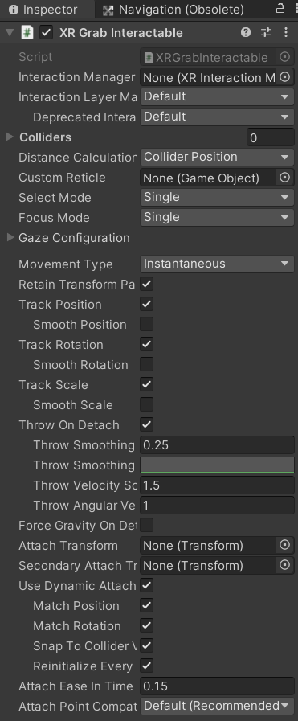

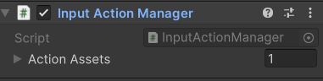

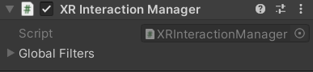

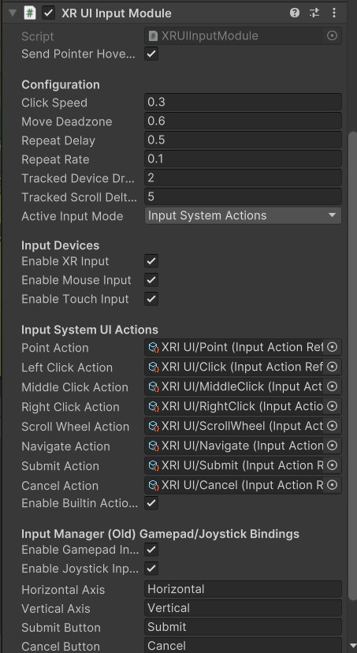

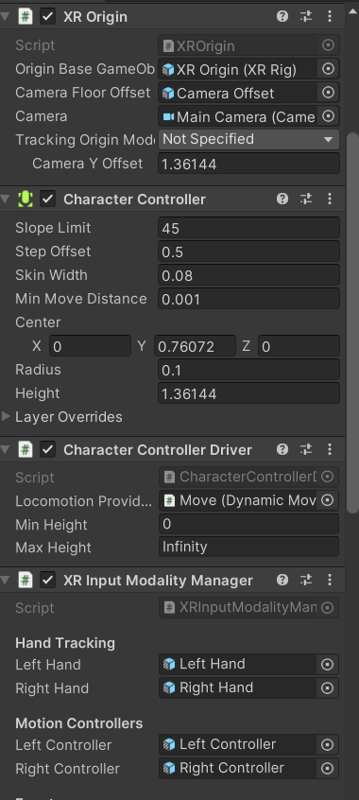

**Task 10:** Demo application [5 marks]

